**Football Data Analysis**

**Today, I am going to do a Data Analysis of Football data.**

**The steps are as follows:**

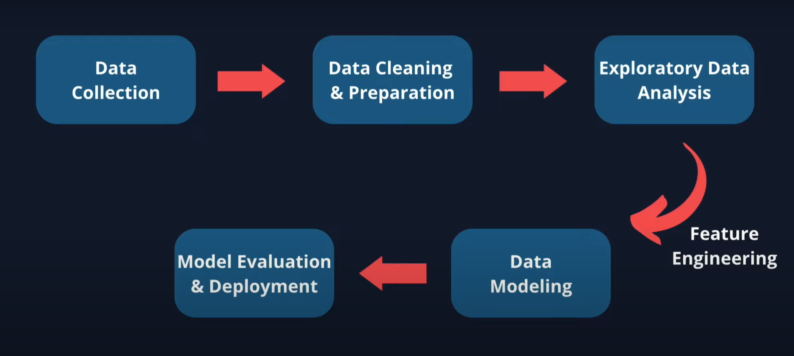

**1). Data Collection:**

**The libraries used are: Pickle, BeautifulSoup,**

**This is done through the python jupyter notebook as mentioned below:**